INDEX

S.NO |  | EXPERIMENT | DATE | T.SIGN
1. | Case Study of Mobile Architecture vs. Computer Architecture
 | with the resent platform
2. | Identify the different SOCs and sensor components required
 | for design and development of small device or a project.
3. | Case study of My Smart Phone Kit and E-Home to explore
 |  | the architecture and programming.
4. | Cross compiling the kernel source code for raspberry pi and
 |  | porting the OS and estimate the booting time.
5. | Basic python programs-Part1: Data types, operators and
 |  | control structures
6. | Basic python programs- Part2: Functions, file handling with
 |  | database
7. |  | Write an android program to make a calculator
8. |  | Write an android program to make a call.
9. |  | Write an android program to send a sms
10. |  | Write an android program to create a form.
11. |  | Write an android program to print your details.
12. | Write a program to interface temperature sensor with
 |  | Raspberry Pi
13. | Write a program to interface Accelerometer with Raspberry
 |  | Pi.
14. | Write a program to interface Bluetooth with Raspberry pi
 | send sensor out to real mobile device through Bluetooth.
15. | Write a program to interface sound sensor with Raspberry Pi
 |  | and make an LED on when sound is detected
16. | Database experiments:
 |  | 1. Using MySQL on a Raspberry Pi
 |  | 2. Accessing a MySQL database with Python
 |  | 3. Getting data from the database
17. | Write a program to capture images at regular interval of 3 sec
 |  | from camera interfaced with raspberry pi.
18. | Write a program to record your voice and play at the end with
 |  | raspberry pi.
19. | GUI Experiments:
 | 1. To create a simple window of Hello Tkinter
 | 2. To create colorized labels.
 | 3. To create a message widget.
 | 4. | To create dynamical content in a Label
 | 5. | To create a button widget

ANDROID EXPERIMENTS

EXPERIMENT-7

AIM: Write an android program to make a calculator.
Hardware required: None
Software required: JAVA, Eclipse.

Theory:

Android is an open source and Linux-based operating system for mobile devices such as smart phones and tablet computers. Android was developed by the Open Handset Alliance, led by Google, and other companies. Android offers a unified approach to application development for mobile devices which means developers need only develop for Android, and their applications should be able to run on different devices powered by Android.

Program Code:

MainActivity.java

package com.calculator;

import android.os.Bundle; import android.app.Activity; import android.view.Menu; import android.view.View;

import android.view.View.OnClickListener; import android.widget.Button;

import android.widget.EditText; import android.widget.TextView;

public class MainActivity extends Activity {

TextView text;

Button btnAdd,btnSub,btnMul,btnDiv,btnPower,btnModule; EditText editf,edits;

@Override

protected void onCreate(Bundle savedInstanceState) { super.onCreate(savedInstanceState); setContentView(R.layout.activity_main); btnAdd=(Button)findViewById(R.id.add); btnSub=(Button)findViewById(R.id.sub); btnMul=(Button)findViewById(R.id.mul); btnDiv=(Button)findViewById(R.id.div); btnPower=(Button)findViewById(R.id.power); btnModule=(Button)findViewById(R.id.modul); text=(TextView)findViewById(R.id.textView1); editf=(EditText)findViewById(R.id.editText1); edits=(EditText)findViewById(R.id.editText2);

btnAdd.setOnClickListener(new OnClickListener() {

@Override
public void onClick(View arg0) {

// TODO Auto-generated method stub String a1=editf.getText().toString(); String b2=edits.getText().toString(); int a=Integer.parseInt(a1);

int b=Integer.parseInt(b2); int result=a+b;

String s=String.valueOf(result); text.setText(s);

}

});

btnSub.setOnClickListener(new OnClickListener() {

@Override

public void onClick(View arg0) {

// TODO Auto-generated method stub String a1=editf.getText().toString(); String b2=edits.getText().toString(); int a=Integer.parseInt(a1);

int b=Integer.parseInt(b2); int result=a-b;

String s=String.valueOf(result); text.setText(s);

}
});
btnMul.setOnClickListener(new OnClickListener() {

@Override

public void onClick(View arg0) {

// TODO Auto-generated method stub String a1=editf.getText().toString(); String b2=edits.getText().toString(); int a=Integer.parseInt(a1);

int b=Integer.parseInt(b2); int result=a*b;

String s=String.valueOf(result); text.setText(s);

}
});
btnDiv.setOnClickListener(new OnClickListener() {

@Override
public void onClick(View arg0) {

// TODO Auto-generated method stub String a1=editf.getText().toString(); String b2=edits.getText().toString(); int a=Integer.parseInt(a1);

int b=Integer.parseInt(b2); int result=a/b;

String s=String.valueOf(result); text.setText(s);

}
});
btnPower.setOnClickListener(new OnClickListener() {

@Override

public void onClick(View arg0) {

// TODO Auto-generated method stub String a1=editf.getText().toString(); String b2=edits.getText().toString(); int a=Integer.parseInt(a1);

int b=Integer.parseInt(b2); int result=a^b;

String s=String.valueOf(result); text.setText(s);

}

});

btnModule.setOnClickListener(new OnClickListener() {

@Override

public void onClick(View arg0) {

// TODO Auto-generated method stub String a1=editf.getText().toString(); String b2=edits.getText().toString(); int a=Integer.parseInt(a1);

int b=Integer.parseInt(b2); int result=a%b;

String s=String.valueOf(result); text.setText(s);

}
});

}

@Override
public 4oolean onCreateOptionsMenu(Menu menu) {
// Inflate the menu; this adds items to the action bar if it is
present.

GetMenuInflater().inflate(R.menu.main, menu); return true;

}

}

activity_main.xml

<RelativeLayout xmlns:android="http://schemas.android.com/apk/res/android" xmlns:tools="http://schemas.android.com/tools" android:layout_width="match_parent" android:layout_height="match_parent" android:paddingBottom="@dimen/activity_vertical_margin" android:paddingLeft="@dimen/activity_horizontal_margin" android:paddingRight="@dimen/activity_horizontal_margin" android:paddingTop="@dimen/activity_vertical_margin" tools:context=".MainActivity" >

<EditText
android:id="@+id/editText1"

android:layout_width="wrap_content" android:layout_height="wrap_content" android:layout_alignParentLeft="true" android:layout_alignParentTop="true" android:layout_marginLeft="16dp" android:layout_marginTop="22dp" android:ems="10"

android:hint="first number" android:inputType="number" />

<EditText

android:id="@+id/editText2" android:layout_width="wrap_content" android:layout_height="wrap_content" android:layout_alignLeft="@+id/editText1" android:layout_below="@+id/editText1" android:layout_marginTop="18dp" android:ems="10"

android:hint="enter second number" android:inputType="number" />

<TextView

android:id="@+id/textView1" android:layout_width="wrap_content" android:layout_height="wrap_content" android:layout_alignLeft="@+id/editText2" android:layout_below="@+id/editText2" android:layout_marginTop="44dp" android:textAppearance="?android:attr/textAppearanceLarge" />

<Button

android:id="@+id/add" android:layout_width="wrap_content" android:layout_height="wrap_content" android:layout_alignParentLeft="true" android:layout_below="@+id/textView1" android:layout_marginLeft="16dp" android:layout_marginTop="65dp" android:text="+" />

<Button

android:id="@+id/sub" android:layout_width="wrap_content" android:layout_height="wrap_content" android:layout_alignBaseline="@+id/add" android:layout_alignBottom="@+id/add" android:layout_centerHorizontal="true" android:text="-" />

<Button
android:id="@+id/mul" android:layout_width="wrap_content" android:layout_height="wrap_content" android:layout_alignBaseline="@+id/sub" android:layout_alignBottom="@+id/sub" android:layout_marginLeft="22dp" android:layout_toRightOf="@+id/sub" android:text="*" />

<Button

android:id="@+id/div" android:layout_width="wrap_content" android:layout_height="wrap_content" android:layout_below="@+id/add" android:layout_marginTop="24dp" android:layout_toLeftOf="@+id/sub" android:text="/" />

<Button

android:id="@+id/power" android:layout_width="wrap_content" android:layout_height="wrap_content" android:layout_alignBottom="@+id/div" android:layout_alignLeft="@+id/sub" android:layout_marginLeft="22dp" android:text="^" />

<Button

android:id="@+id/modul" android:layout_width="wrap_content" android:layout_height="wrap_content" android:layout_alignBottom="@+id/power" android:layout_alignParentRight="true" android:text="%" />

</RelativeLayout>

Output
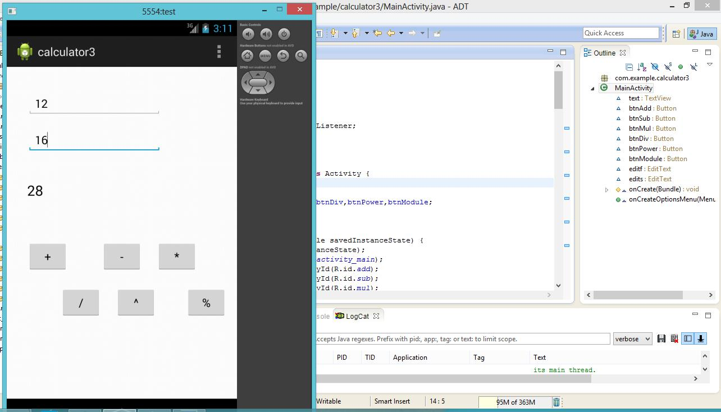

Conclusion:

We are successfully able to make a calculator using Eclipse.

EXPERIMENT: 8

Aim: Write an android program to make a call.
Hardware required: None
Software required: JAVA, Eclipse.

Theory:

Android is an open source and Linux-based operating system for mobile devices such as smartphones and tablet computers. Android was developed by the Open Handset Alliance, led by Google, and other companies. Android offers a unified approach to application development for mobile devices which means developers need only develop for Android, and their applications should be able to run on different devices powered by Android.

Program Code:

MainActivity.java

package com.calling;

import android.net.Uri; import android.os.Bundle; import android.app.Activity; import android.content.Intent; import android.view.Menu; import android.view.View;

import android.view.View.OnClickListener; import android.widget.Button;

import android.widget.EditText;

public class MainActivity extends Activity { EditText number;

Button btncall; Intent in; @Override

protected void onCreate(Bundle savedInstanceState) { super.onCreate(savedInstanceState); setContentView(R.layout.activity_main); number=(EditText)findViewById(R.id.number); btncall=(Button)findViewById(R.id.callbutton); btncall.setOnClickListener(new OnClickListener() {

@Override
public void onClick(View arg0)
{

String a1=number.getText().toString(); //int a=Integer.parseInt(a1); //String s=String.valueOf(a);

in =new Intent(Intent.ACTION_CALL); in.setData(Uri.parse("tel:"+a1)); startActivity(in);

}
})
}
@Override

public boolean onCreateOptionsMenu(Menu menu) {

// Inflate the menu; this adds items to the action bar if it is

present.

getMenuInflater().inflate(R.menu.main, menu); return true;

}

}

activity_main.xml

<RelativeLayout

xmlns:android="http://schemas.android.com/apk/res/android"

xmlns:tools="http://schemas.android.com/tools" android:layout_width="match_parent" android:layout_height="match_parent" android:paddingBottom="@dimen/activity_vertical_margin" android:paddingLeft="@dimen/activity_horizontal_margin" android:paddingRight="@dimen/activity_horizontal_margin" android:paddingTop="@dimen/activity_vertical_margin" tools:context=".MainActivity" >

<TextView

android:id="@+id/textView1" android:layout_width="wrap_content" android:layout_height="wrap_content" android:layout_alignParentLeft="true" android:layout_alignParentTop="true" android:layout_marginTop="20dp" android:text="Enter your number"
android:textAppearance="?android:attr/textAppearanceLarge" />

<EditText

android:id="@+id/number" android:layout_width="wrap_content" android:layout_height="wrap_content" android:layout_alignLeft="@+id/textView1" android:layout_below="@+id/textView1" android:layout_marginTop="18dp" android:ems="10"

android:hint="enter phone number" android:inputType="phone" />

<Button

android:id="@+id/callbutton" android:layout_width="wrap_content" android:layout_height="wrap_content" android:layout_alignLeft="@+id/number" android:layout_below="@+id/number" android:layout_marginTop="47dp" android:text="Call" />

</RelativeLayout>

Output
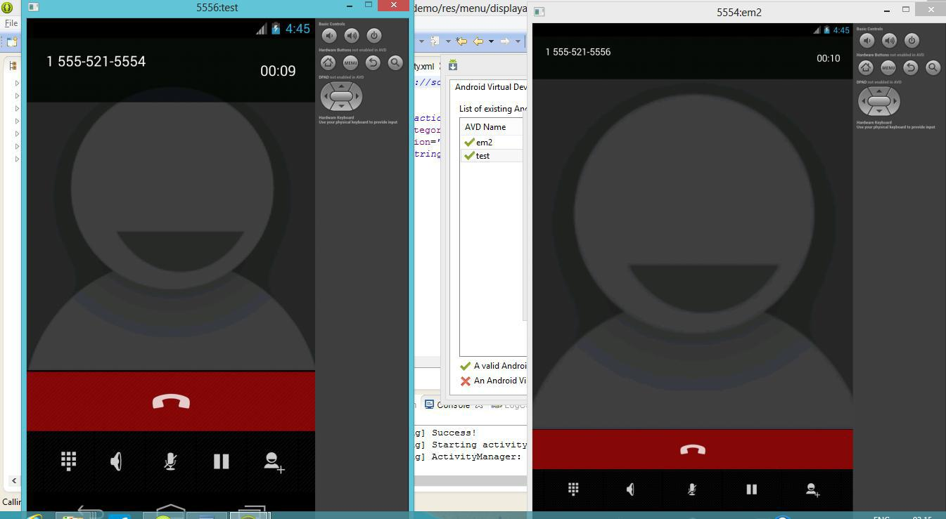

Conclusion:

We are successfully able to make a call using Eclipse.
EXPERIMENT: 9

AIM: Write an android program to send a sms.
Hardware required: None
Software required: JAVA, Eclipse.

Theory:

Android is an open source and Linux-based operating system for mobile devices such as smartphones and tablet computers. Android was developed by the Open Handset Alliance, led by Google, and other companies. Android offers a unified approach to application development for mobile devices which means developers need only develop for Android, and their applications should be able to run on different devices powered by Android.

Program Code:

MainActivity.java

package com.example.smssend;

import android.os.Bundle; import android.app.Activity;

import android.telephony.SmsManager; import android.view.Menu;

import android.view.View;

import android.view.View.OnClickListener; import android.widget.Button;

import android.widget.EditText;

public class MainActivity extends Activity {

EditText n,m; @Override

protected void onCreate(Bundle savedInstanceState) { super.onCreate(savedInstanceState); setContentView(R.layout.activity_main); n=(EditText)findViewById(R.id.editText1); m=(EditText)findViewById(R.id.editText2);

Button btnSendSms=(Button)findViewById(R.id.button1); btnSendSms.setOnClickListener(new OnClickListener()
{

@Override

public void onClick(View arg0)

{

String n1= n.getText().toString(); String m1= m.getText().toString();

SmsManager sm=SmsManager.getDefault(); sm.sendTextMessage(n1, null, m1, null, null);

}

});
}

@Override

public boolean onCreateOptionsMenu(Menu menu) {

// Inflate the menu; this adds items to the action bar if it is

present.

getMenuInflater().inflate(R.menu.main, menu); return true;

}

}

activity_main.xml

<RelativeLayout

xmlns:android="http://schemas.android.com/apk/res/android"

xmlns:tools="http://schemas.android.com/tools" android:layout_width="match_parent" android:layout_height="match_parent" android:paddingBottom="@dimen/activity_vertical_margin" android:paddingLeft="@dimen/activity_horizontal_margin" android:paddingRight="@dimen/activity_horizontal_margin" android:paddingTop="@dimen/activity_vertical_margin" tools:context=".MainActivity" >

<Button
android:id="@+id/button1"

style="?android:attr/buttonStyleSmall" android:layout_width="wrap_content" android:layout_height="wrap_content" android:layout_alignParentTop="true" android:layout_centerHorizontal="true" android:layout_marginTop="191dp" android:text="SendSms" />

<EditText

android:id="@+id/editText1" android:layout_width="wrap_content" android:layout_height="wrap_content" android:layout_alignParentTop="true" android:layout_alignRight="@+id/button1" android:layout_marginRight="27dp" android:layout_marginTop="42dp" android:ems="10" android:inputType="phone" >

<requestFocus /> </EditText>

<EditText

android:id="@+id/editText2" android:layout_width="wrap_content" android:layout_height="wrap_content" android:layout_alignLeft="@+id/editText1" android:layout_below="@+id/editText1" android:layout_marginLeft="14dp" android:layout_marginTop="25dp" android:ems="10" />

</RelativeLayout>

Output:
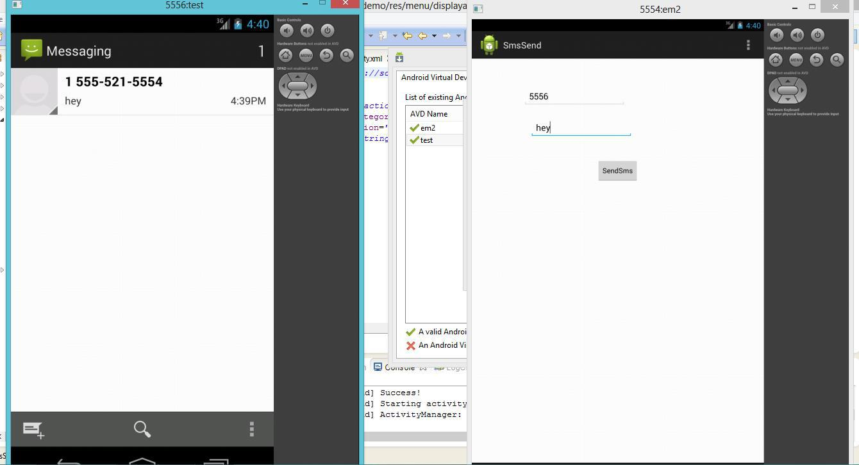

Conclusion:

We are successfully able to send a sms using eclispse.

EXPERIMENT: 9

AIM: Write an android program to create a form.
Hardware required: None
Software required: JAVA, Eclipse.

Theory:

Android is an open source and Linux-based operating system for mobile devices such as smartphones and tablet computers. Android was developed by the Open Handset Alliance, led by Google, and other companies. Android offers a unified approach to application development for mobile devices which means developers need only develop for Android, and their applications should be able to run on different devices powered by Android.

Program Code:

MainActivity.java

package com.formdemo;

import android.os.Bundle; import android.app.Activity; import android.content.Intent; import android.view.Menu; import android.widget.TextView;

public class Displayactivity extends Activity { TextView namedisplay,agedisplay,genderdisplay;

@Override

protected void onCreate(Bundle savedInstanceState) { super.onCreate(savedInstanceState); setContentView(R.layout.activity_displayactivity); namedisplay=(TextView)findViewById(R.id.namedisplay); agedisplay=(TextView)findViewById(R.id.agedisplay); genderdisplay=(TextView)findViewById(R.id.genderdisplay); Intent in=getIntent(); namedisplay.setText(in.getStringExtra("n1")); agedisplay.setText(in.getStringExtra("n2")); genderdisplay.setText(in.getStringExtra("n3"));

}

@Override

public boolean onCreateOptionsMenu(Menu menu) {

// Inflate the menu; this adds items to the action bar if it

is present.

getMenuInflater().inflate(R.menu.displayactivity, menu); return true;

}

}
activity_main.xml

<RelativeLayout xmlns:android="http://schemas.android.com/apk/res/android" xmlns:tools="http://schemas.android.com/tools" android:layout_width="match_parent" android:layout_height="match_parent" android:paddingBottom="@dimen/activity_vertical_margin" android:paddingLeft="@dimen/activity_horizontal_margin" android:paddingRight="@dimen/activity_horizontal_margin" android:paddingTop="@dimen/activity_vertical_margin" tools:context=".Displayactivity" >

<TextView

android:id="@+id/textView1" android:layout_width="wrap_content" android:layout_height="wrap_content" android:layout_alignParentLeft="true" android:layout_alignParentTop="true" android:layout_marginTop="48dp" android:text="Name--"

android:textAppearance="?android:attr/textAppearanceMedium" />

<TextView

android:id="@+id/textView2" android:layout_width="wrap_content" android:layout_height="wrap_content" android:layout_alignLeft="@+id/textView1" android:layout_below="@+id/textView1" android:layout_marginTop="26dp" android:text="Age--"
android:textAppearance="?android:attr/textAppearanceMedium" />

<TextView

android:id="@+id/textView3" android:layout_width="wrap_content" android:layout_height="wrap_content" android:layout_alignParentLeft="true" android:layout_below="@+id/textView2" android:layout_marginTop="36dp" android:text="Gender--"
android:textAppearance="?android:attr/textAppearanceMedium" />

<TextView

android:id="@+id/namedisplay" android:layout_width="wrap_content" android:layout_height="wrap_content" android:layout_alignTop="@+id/textView1" android:layout_centerHorizontal="true" android:textAppearance="?android:attr/textAppearanceLarge" />

OUTPUT :
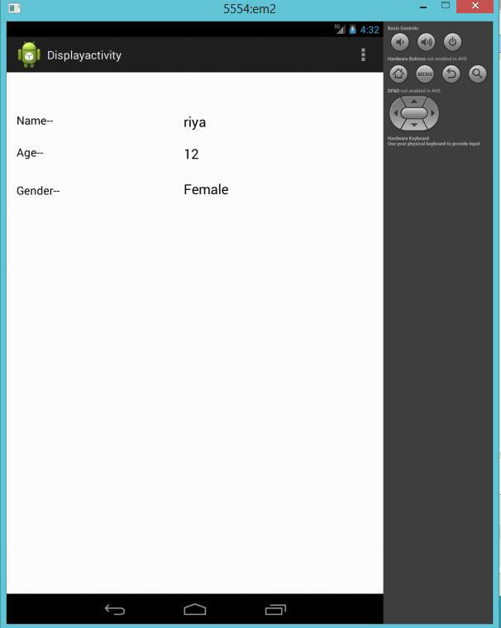

Conclusion:

We are successfully able to create a form using eclipse.
EXPERIMENT: 10

AIM: Write an android program to print your details.
Hardware required: None
Software required: JAVA, Eclipse.

Program Code:

MainActivity.java

package com.example.details; import android.os.Bundle; import android.app.Activity; import android.view.Menu;

public class MainActivity extends Activity { @Override

protected void onCreate(Bundle savedInstanceState) { super.onCreate(savedInstanceState); setContentView(R.layout.activity_main);

}
@Override
public boolean onCreateOptionsMenu(Menu menu) {

// Inflate the menu; this adds items to the action bar if it is present. getMenuInflater().inflate(R.menu.main, menu);

return true;
}
}

activity_main.xml

<RelativeLayout xmlns:android="http://schemas.android.com/apk/res/android" xmlns:tools="http://schemas.android.com/tools" android:layout_width="match_parent" android:layout_height="match_parent" android:paddingBottom="@dimen/activity_vertical_margin" android:paddingLeft="@dimen/activity_horizontal_margin" android:paddingRight="@dimen/activity_horizontal_margin" android:paddingTop="@dimen/activity_vertical_margin" tools:context=".MainActivity" >

<TextView android:layout_width="wrap_content" android:layout_height="wrap_content" android:layout_alignTop="@+id/textView1" android:layout_centerHorizontal="true" android:text="MAP Assignment- Group 3\n" android:textSize="16dp"

/>
<TextView
android:id="@+id/textView1"

android:layout_width="wrap_content" android:layout_height="wrap_content" android:text="

\n\n\t\t\t\t\tRia Pant \n

Mitanshi Rastogi\n

Sonali Bansal\n

Shubhi Lohani\n

Sakshi Jain\n

\n\t\t\t\t\tIGDTUW\n

\n\t\t\t\t\tCSE B.Tech\n

" />

</RelativeLayout>
Output:
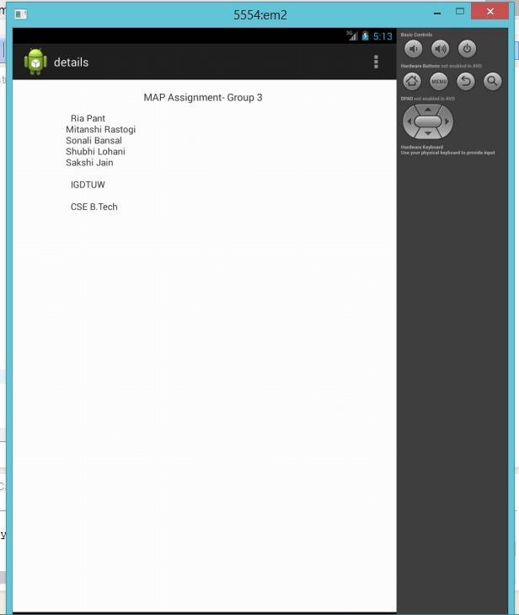

Conclusion:

We are able to display the details successfully using eclipse.
DATABASE EXPERIMENTS

EXPERIMENT NO. 16 (i)

AIM: Using MySQL on a Raspberry Pi

THEORY: SQLite is a great database for many situations, but there are times when it's not quite up to the job. SQLite can be used in web sites, but it's much more common to use MySQL. This is because

- MySQL is more scalable,
- MySQL can be tuned more easily,
- it supports user management and permissions,
- MySQL is better for sites with heavy traffic,

- it can be used in client server architectures where a database client must access a database remotely.

Software Requirements: Python is main programming language on raspberry pi.

- LEAFPAD: This is a tab inbuilt in raspberry pi. Programs are written in this tab. Opening procedure of a leafpad is showing in fig-1.

- Python libraries should be updated and it will also require internet connection.

Procedure: Setting up MySQL on a Raspberry Pi

Step 1: Before we get started, we need to install MySQL server and the Python bindings for MySQL:

sudo apt-get install mysql-server python-mysqldb

Step 2: During the installation of MySQL server, you will be prompted to enter a password for the MySQL root account.

We will create a database to log temperatures. First of all we will create a database named temps to store records with fields for a date, time, zone and temperature.

Like SQLite, MySQL comes with a shell that can be used for configuration. We can use the the MySQL shell to create a database:

$ mysql -u root -p Enter password:

mysql> CREATE DATABASE temps mysql> USE temps

The 'USE temps' command tells the shell to use that database in future operations in this shell session.

Step 3: MySQL supports users accounts, so we need to create a database user and give it access to the database:

mysql> CREATE USER 'monitor'@'localhost' IDENTIFIED BY 'password'; mysql> GRANT ALL PRIVILEGES ON temps.* TO 'monitor'@'localhost' mysql> FLUSH PRIVILEGES;

mysql> quit

This creates a user called monitor (because the database is going to be accessed by a program that monitors temperatures), and assigns it a pass word 'password'. This user is allowed to connect to the database from 'localhost'.

Initially, the new user has no privileges, so it must be granted some access rights using the 'GRANT' command..

The last command quits the shell so that we can re-enter the shell as the user that we just created:

mysql -u monitor -p

Step 4: Now lets create a table with the fields needed for storing data:

CREATE TABLE tempdat (tdate DATE, ttime TIME, zone TEXT, temperature NUMERIC);

PROGRAM CODE:

sudo apt-get install mysql-server python-mysqldb $ mysql -u root -p
Enter password:

mysql> CREATE DATABASE temps mysql> USE temps

mysql> CREATE USER 'monitor'@'localhost' IDENTIFIED BY 'password'; mysql> GRANT ALL PRIVILEGES ON temps.* TO 'monitor'@'localhost' mysql> FLUSH PRIVILEGES;

mysql> quit
mysql -u monitor -p

CREATE TABLE tempdat (tdate DATE, ttime TIME, zone TEXT, temperature NUMERIC);
OUTPUT:
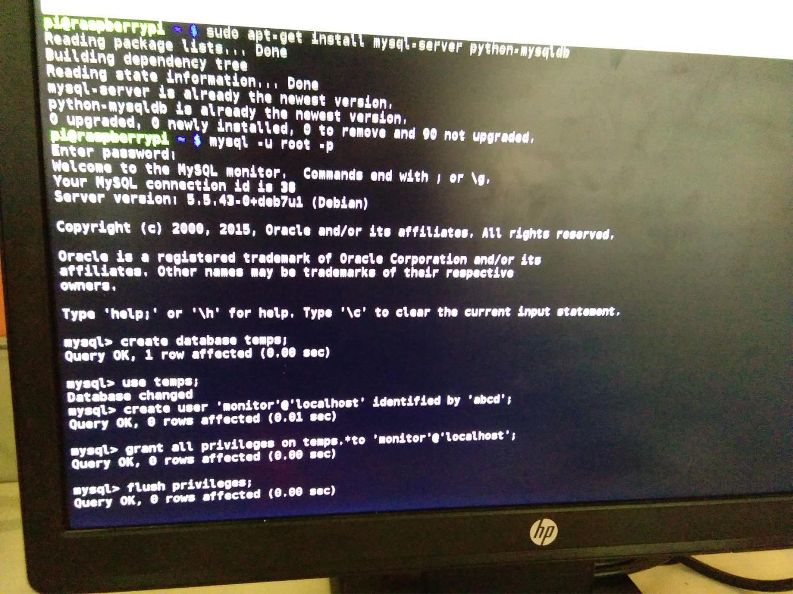

Result: My SQL on Rpi has been installed
EXPERIMENT NO.16(ii)

AIM: Accessing a MySQL database with Python

THEORY: SQLite is a great database for many situations, but there are times when it's not quite up to the job. SQLite can be used in web sites, but it's much more common to use MySQL. This is because

- MySQL is more scalable,
- MySQL can be tuned more easily,
- it supports user management and permissions,
- MySQL is better for sites with heavy traffic,

- it can be used in client server architectures where a database client must access a database remotely.

Software Requirements: Python is main programming language on raspberry pi.

- LEAFPAD: This is a tab inbuilt in raspberry pi. Programs are written in this tab. Opening procedure of a leafpad is showing in fig-1.

- Python libraries should be updated and it will also require internet connection.

Procedure: we will use Python to populate the database and we will record temperatures in three different zones.

This Python code is the start of our script:

#!/usr/bin/env python

import MySQLdb

db = MySQLdb.connect("localhost", "monitor", "password", "temps") curs=db.cursor()

First of all we import the MySQLdb python module and connect to it with the user name and password that was set up in the shell. The following code then inserts records into the database:

# you can use one set of double quotes if you put the whole string on one line try:

curs.execute ("""INSERT INTO tempdat

values(CURRENT_DATE() - INTERVAL 1 DAY, NOW(), 'kitchen', 21.7)""") curs.execute ("""INSERT INTO tempdat

values(CURRENT_DATE() - INTERVAL 1 DAY, NOW(), 'greenhouse', 24.5)""") curs.execute ("""INSERT INTO tempdat

values(CURRENT_DATE() - INTERVAL 1 DAY, NOW(), 'garage', 18.1)""")

curs.execute ("""INSERT INTO tempdat

values(CURRENT_DATE(), NOW() - INTERVAL 12 HOUR, 'kitchen', 20.6)""") curs.execute ("""INSERT INTO tempdat

values(CURRENT_DATE(), NOW() - INTERVAL 12 HOUR, 'greenhouse', 17.1)""")

curs.execute ("""INSERT INTO tempdat
values(CURRENT_DATE(), NOW() - INTERVAL 12 HOUR, 'garage', 16.2)""")

curs.execute ("""INSERT INTO tempdat values(CURRENT_DATE(), NOW(), 'kitchen', 22.9)""")

curs.execute ("""INSERT INTO tempdat values(CURRENT_DATE(), NOW(), 'greenhouse', 25.7)""")

curs.execute ("""INSERT INTO tempdat values(CURRENT_DATE(), NOW(), 'garage', 18.2)""")

db.commit()
print "Data committed"

except:

print "Error: the database is being rolled back" db.rollback()

If there's an error during any of these SQL commands, or if there's an error while committing the changes, the changes will be rolled back. This can be simplified using a Python context manager:

with db:
curs.execute ("""INSERT INTO tempdat

values(CURRENT_DATE() - INTERVAL 1 DAY, NOW(), 'kitchen', 21.7)""") curs.execute ("""INSERT INTO tempdat

values(CURRENT_DATE() - INTERVAL 1 DAY, NOW(), 'greenhouse', 24.5)""") curs.execute ("""INSERT INTO tempdat

values(CURRENT_DATE() - INTERVAL 1 DAY, NOW(), 'garage', 18.1)""")

curs.execute ("""INSERT INTO tempdat

values(CURRENT_DATE(), NOW() - INTERVAL 12 HOUR, 'kitchen', 20.6)""") curs.execute ("""INSERT INTO tempdat

values(CURRENT_DATE(), NOW() - INTERVAL 12 HOUR, 'greenhouse', 17.1)""")

curs.execute ("""INSERT INTO tempdat
values(CURRENT_DATE(), NOW() - INTERVAL 12 HOUR, 'garage', 16.2)""")

curs.execute ("""INSERT INTO tempdat values(CURRENT_DATE(), NOW(), 'kitchen', 22.9)""")

curs.execute ("""INSERT INTO tempdat values(CURRENT_DATE(), NOW(), 'greenhouse', 25.7)""")

curs.execute ("""INSERT INTO tempdat values(CURRENT_DATE(), NOW(), 'garage', 18.2)""")

This will automatically handle commit and rollback operations.

PROGRAM CODE

#!/usr/bin/env python

import MySQLdb

db = MySQLdb.connect("localhost", "root", "root", "temp") curs=db.cursor()

# you can use one set of double quotes if you put the whole string on one line

try:

curs.execute ("""INSERT INTO tempdat

values(CURRENT_DATE() - INTERVAL 1 DAY, NOW(), 'kitchen',

21.7)""")

curs.execute ("""INSERT INTO tempdat values(CURRENT_DATE() - INTERVAL 1 DAY, NOW(),

'greenhouse', 24.5)""")

curs.execute ("""INSERT INTO tempdat

values(CURRENT_DATE() - INTERVAL 1 DAY, NOW(), 'garage',
18.1)""")

curs.execute ("""INSERT INTO tempdat
values(CURRENT_DATE(), NOW() - INTERVAL 12 HOUR, 'kitchen',
20.6)""")

curs.execute ("""INSERT INTO tempdat values(CURRENT_DATE(), NOW() - INTERVAL 12 HOUR,
'greenhouse', 17.1)""")
curs.execute ("""INSERT INTO tempdat

values(CURRENT_DATE(), NOW() - INTERVAL 12 HOUR, 'garage',
16.2)""")

curs.execute ("""INSERT INTO tempdat values(CURRENT_DATE(), NOW(), 'kitchen', 22.9)""")
curs.execute ("""INSERT INTO tempdat

values(CURRENT_DATE(), NOW(), 'greenhouse', 25.7)""") curs.execute ("""INSERT INTO tempdat

values(CURRENT_DATE(), NOW(), 'garage', 18.2)""")

db.commit()
print "Data committed"

except:

print "Error: the database is being rolled back" db.rollback()

curs.execute ("""INSERT INTO tempdat
values(CURRENT_DATE() - INTERVAL 1 DAY, NOW(), 'kitchen',
21.7)""")

curs.execute ("""INSERT INTO tempdat values(CURRENT_DATE() - INTERVAL 1 DAY, NOW(),

'greenhouse', 24.5)""")
curs.execute ("""INSERT INTO tempdat
values(CURRENT_DATE() - INTERVAL 1 DAY, NOW(), 'garage',

18.1)""")

curs.execute ("""INSERT INTO tempdat

values(CURRENT_DATE(), NOW() - INTERVAL 12 HOUR, 'kitchen',

20.6)""")

curs.execute ("""INSERT INTO tempdat values(CURRENT_DATE(), NOW() - INTERVAL 12 HOUR,
'greenhouse', 17.1)""")

curs.execute ("""INSERT INTO tempdat

values(CURRENT_DATE(), NOW() - INTERVAL 12 HOUR, 'garage',

16.2)""")

curs.execute ("""INSERT INTO tempdat values(CURRENT_DATE(), NOW(), 'kitchen', 22.9)""")

curs.execute ("""INSERT INTO tempdat

values(CURRENT_DATE(), NOW(), 'greenhouse', 25.7)""") curs.execute ("""INSERT INTO tempdat

values(CURRENT_DATE(), NOW(), 'garage', 18.2)""")

OUTPUT
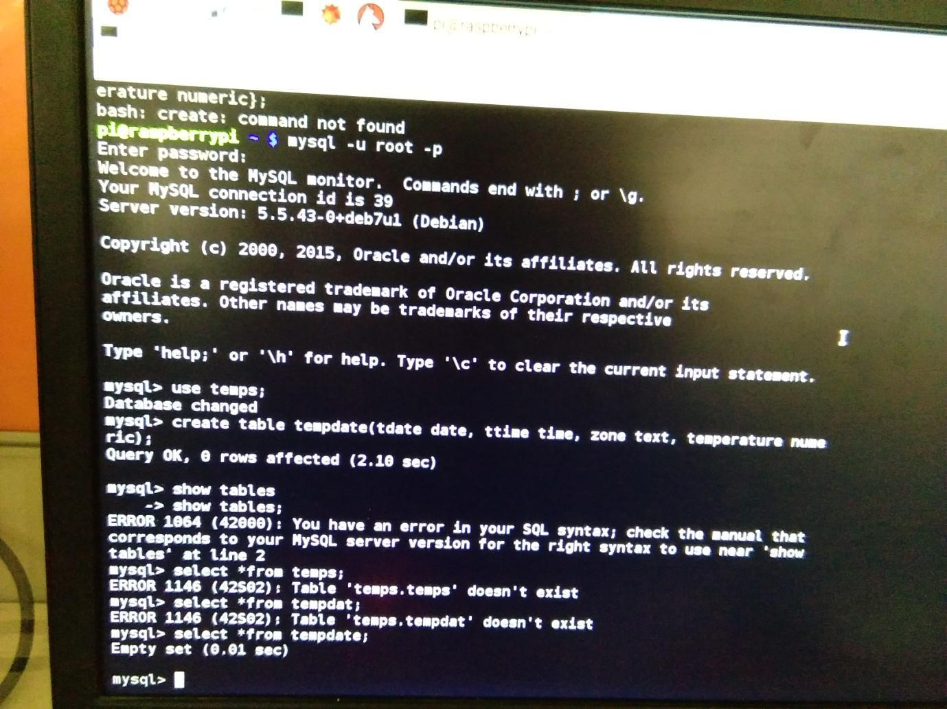

Result: My SQL database has been accessed with python.
EXPERIMENT 16(iii)

AIM: Getting data from the database

THEORY: SQLite is a great database for many situations, but there are times when it's not quite up to the job. SQLite can be used in web sites, but it's much more common to use MySQL. This is because

- MySQL is more scalable,
- MySQL can be tuned more easily,
- it supports user management and permissions,
- MySQL is better for sites with heavy traffic,

- it can be used in client server architectures where a database client must access a database remotely.

Software Requirements: Python is main programming language on raspberry pi.

- LEAFPAD: This is a tab inbuilt in raspberry pi. Programs are written in this tab. Opening procedure of a leafpad is showing in fig-1.

- Python libraries should be updated and it will also require internet connection.

Procedure: Once data has been inserted into the database, we need to be able to retrieve it. We can do this using the SQL select command. The execute function runs the SQL query, and the fetchall function returns a list of records that matched the query:

curs.execute ("SELECT * FROM tempdat")
print "\nDate | Time | Zone | Temperature"
print "==========================================================="

for reading in curs.fetchall():
print str(reading[0])+" "+str(reading[1])+" "+\
reading[2]+" "+str(reading[3])

The for loop iterates through the list of results. Each record is a list of values. Note that the time and the temperature values have to be converted to a string before they can be appended to the result string. This code prints the contents of the entire database as a table:

Date Time Zone Temperature
===========================================================
2013-09-09 | 14:41:46 kitchen |  | 21.7
2013-09-09 | 14:41:46 greenhouse |  |  | 24.5
2013-09-09 | 14:41:46 garage |  | 18.1
2013-09-10 | 2:41:46 | kitchen | 20.6
2013-09-10 | 2:41:46 | greenhouse |  | 17.1
2013-09-10 | 2:41:46 | garage | 16.2

2013-09-10 | 14:41:46 kitchen | 22.9
2013-09-10 | 14:41:46 greenhouse |  | 25.7
2013-09-10 | 14:41:46 garage | 18.2

We can use the WHERE keyword to attach conditions to a query. In this example, we will search for records where the temperature is above 20.0 degrees:

curs.execute ("SELECT * FROM tempdat WHERE temp>%s", (str(20.0),))

Note that it's important not to use string substitution to insert parameters into the query as this makes it easier for people to inject malicious SQL code into a query. This query does the same thing, but it's less secure:

curs.execute ("SELECT * FROM tempdat WHERE temp>%s" % str(20.0))

In this example, the variable is unconditionally inserted into the query. In the previous one, the query and the parameter are passed to the MySQL library, which checks to see if the parameter is safe before inserting it.

The output from this query is

Date Time Zone Temperature
===========================================================
2013-09-09 | 14:41:46 kitchen | 21.7
2013-09-09 | 14:41:46 greenhouse |  | 24.5
2013-09-10 | 2:41:46 kitchen | 20.6
2013-09-10 | 14:41:46 kitchen | 22.9
2013-09-10 | 14:41:46 greenhouse |  | 25.7

At the end of the script, we close the connection to the database:

db.close()

PROGRAM CODE:
#!/usr/bin/env python

import MySQLdb

db = MySQLdb.connect("localhost", "monitor", "abcd", "temps") curs=db.cursor()

curs.execute ("SELECT * FROM tempdate")
Print | "\nDate | Time | Zone | Temperature"
Print | "==========================================================="

for reading in curs.fetchall():

print str(reading[0])+" "+str(reading[1])+" "+\ reading[2]+" "+str(reading[3])

curs.execute ("SELECT * FROM tempdate WHERE temperature>%s", (str(20.0),))

curs.execute ("SELECT * FROM tempdate WHERE temperature>%s" % str(20.0))

db.close()

OUTPUT:
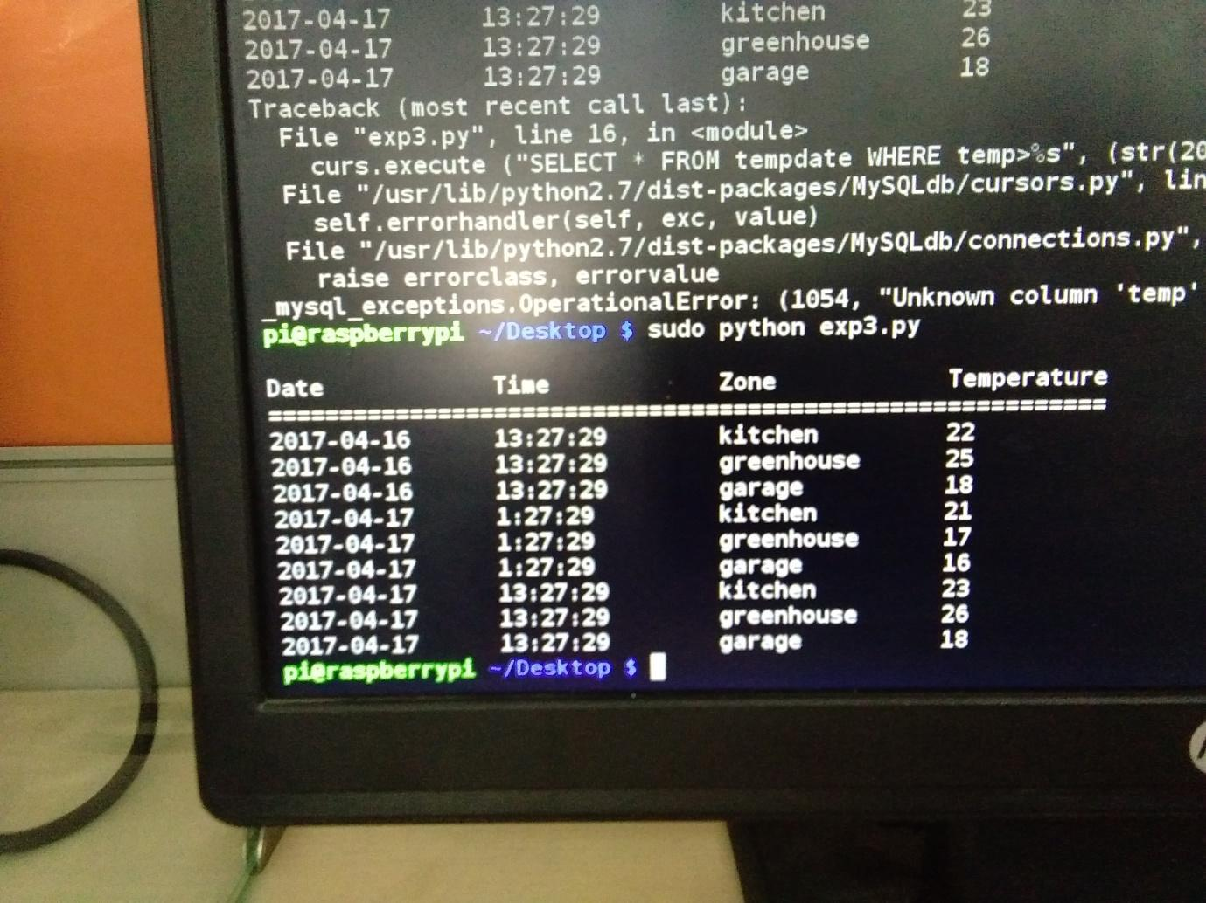

Result: Data is received from database
GUI EXPERIMENTS

EXPERIMENT No. 19(i)

AIM: To create a simple window of Hello Tkinter

Hardware required: Raspberry Pi.
Software required: Python, My_OS

Theory:

Graphical user interface (GUI) is a visual way of interacting with a computer using items such as windows, icons, and menus, used by most modern operating systems. Tkinter is

Python’s Standard GUI (Graphical User Interface). It is included with the standard Microsoft Windows and Mac OS X install of Python.

CODE:

from tkinter import *

# if you are working under Python 2, comment the previous line and comment out the following line

#from Tkinter import *

root = Tk()

w = Label(root, text="Hello Tkinter!")

w.pack()

root.mainloop()

OUTPUT
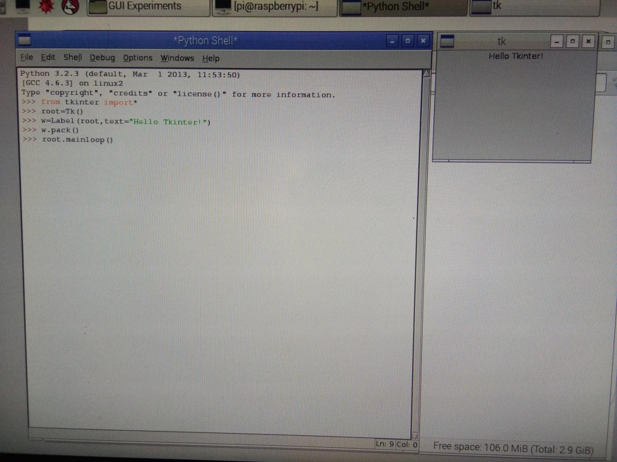

Result : A simple window of Hello Tkinter has been created using GUI.
EXPERIMENT No. 19(ii)

AIM: To create colorized labels.

Hardware required: Raspberry Pi.
Software required: Python, My_OS

Theory:

Graphical user interface (GUI) is a visual way of interacting with a computer using items such as windows, icons, and menus, used by most modern operating systems. Tkinter is

Python’s Standard GUI (Graphical User Interface). It is included with the standard Microsoft Windows and Mac OS X install of Python.

CODE:
from tkinter import *

root = Tk()

Label(root,

text="Red Text in Times Font",

fg = "red",

font = "Times").pack()

Label(root,

text="Green Text in Helvetica Font",

fg = "light green",

bg = "dark green",

font = "Helvetica 16 bold italic").pack()

Label(root,

text="Blue Text in Verdana bold",

fg = "blue",

bg = "yellow",

font = "Verdana 10 bold").pack()

root.mainloop()

OUTPUT:
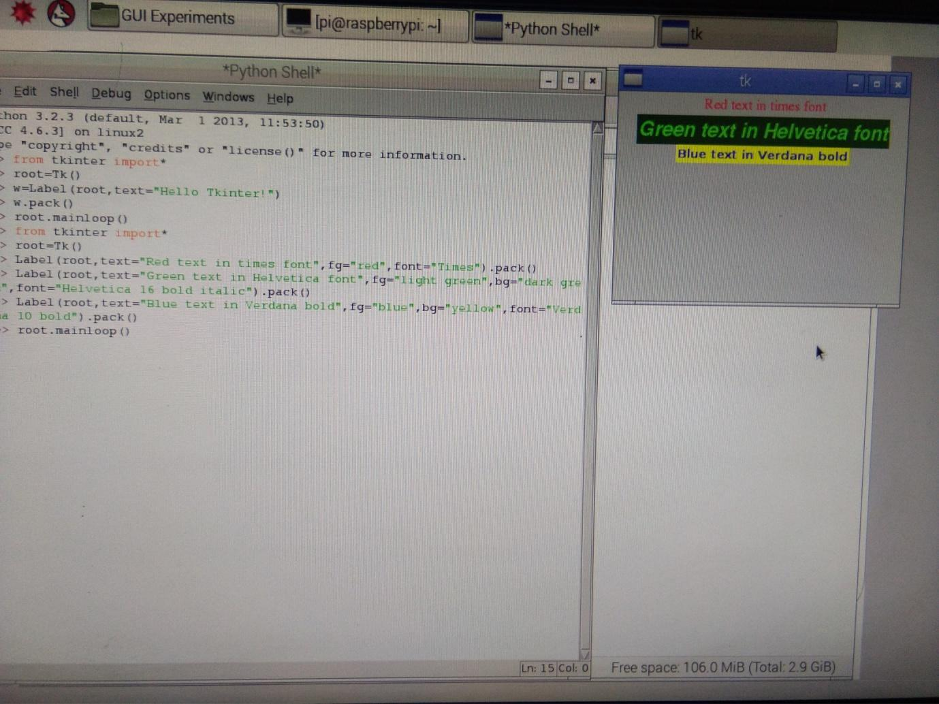

Result: Colorized labels has been created using GUI.

EXPERIMENT No. 19(iii)

AIM: To create a message widget
Hardware required: Raspberry Pi.

Software required: Python, My_OS

Theory:

Graphical user interface (GUI) is a visual way of interacting with a computer using items such as windows, icons, and menus, used by most modern operating systems. Tkinter is

Python’s Standard GUI (Graphical User Interface). It is included with the standard Microsoft Windows and Mac OS X install of Python.

CODE:
from tkinter import *

master = Tk()

whatever_you_do = "Whatever you do will be insignificant, but it is very important that you do it.\n(Mahatma Gandhi)"

msg = Message(master, text = whatever_you_do)

msg.config(bg='lightgreen', font=('times', 24, 'italic'))

msg.pack( )

mainloop( )

OUTPUT
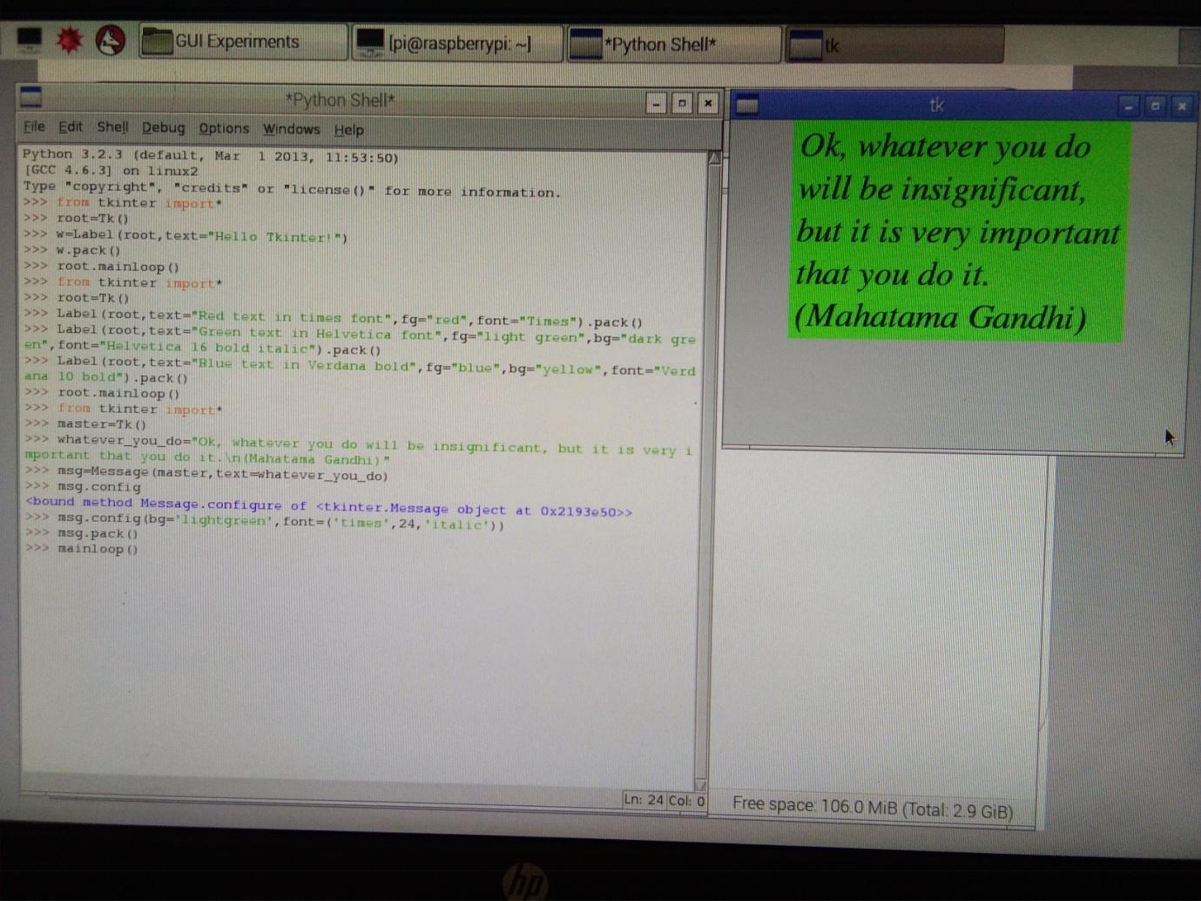

Result: Message widget has been created using GUI.
EXPERIMENT No. 19(iv)

AIM: To create dynamical content in a Label

Hardware required: Raspberry Pi.
Software required: Python, My_OS
Theory:

Graphical user interface (GUI) is a visual way of interacting with a computer using items such as windows, icons, and menus, used by most modern operating systems. Tkinter is

Python’s Standard GUI (Graphical User Interface). It is included with the standard Microsoft Windows and Mac OS X install of Python.

CODE:
import tkinter as tk

counter = 0

def counter_label(label):

def count():

global counter

counter += 1

label.config(text=str(counter))

label.after(1000, count)

count()

root = tk.Tk()

root.title("Counting Seconds")

label = tk.Label(root, fg="green")

label.pack()

counter_label(label)

button = tk.Button(root, text='Stop', width=25, command=root.destroy)

button.pack()

root.mainloop()
OUTPUT:
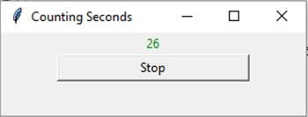

Result : Dynamical content in a Label has been created using GUI.
EXPERIMENT No. 19(v)
Aim : To create a button widget

Hardware required: Raspberry Pi.

Software required: Python, My_OS

Theory:

Graphical user interface (GUI) is a visual way of interacting with a computer using items such as windows, icons, and menus, used by most modern operating systems. Tkinter is

Python’s Standard GUI (Graphical User Interface). It is included with the standard Microsoft Windows and Mac OS X install of Python.

CODE:
from tkinter import *

class App:

def __init__(self, master):

frame = Frame(master)

frame.pack()

self.button = Button(frame,

text="QUIT", fg="red",

command=quit)

self.button.pack(side=LEFT)

self.slogan = Button(frame,

text="Hello",

command=self.write_slogan)

self.slogan.pack(side=LEFT)

def write_slogan(self):

print("Tkinter is easy to use!")

root = Tk()

app = App(root)

root.mainloop()

OUTPUT:
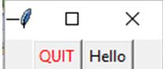

Result: Button widget has been created using GUI.

